**To:** Robert Dana, Jeff Hecker, Mike Scott, Maine Journal Project Staff, Maine Journal Advisory Group

**From:** Samuel Foster

**Date:** May 18th, 2012

**Subject:** Maine Journal Project Year End Report (2011-2012)

The Maine Journal Project publication was created based on the idea that there is excellent undergraduate work from a variety of disciplines at the University of Maine. The Maine Journal Project’s goal is to showcase excellent undergraduate work by developing a mobile application for distribution.

Alexander Morrow, Samuel Foster, and Joshua Komusin led the Maine Journal Project Staff. The staff consisted of thirteen additional undergraduates from the disciplines of Economics, New Media, Marine Biology, Computer Science, History and English, Journalism, Environmental Horticulture, and Computer and Electrical Engineering.

**Fall 2011-Spring 2012**

Much of the 2011-2012 year was spent conceptualizing components of the Journal such as how content would be discovered and collected and how we could accurately represent many types of student work on a mobile device. The variety of disciplines that our staff encompassed provided us with a multitude of perspectives, resulting in a firm foundation. In addition to conceptualizing members of the Maine Journal Project staff also met with various University of Maine faculties to learn about upcoming undergraduate events and to further brainstorm how the content would be delivered. From these discussions, three “teams” were created handle various aspects of the project: Content, Design, and Database.

The Content Team focused on discovering exemplary undergraduate work, gathering content, and producing articles for the Maine Journal Project. Ten students of varying disciplines were uncovered based on recognition within their major (The Grady Awards, Student Art Shows, etc.) and recommendation from faculty. The Content Team worked closely with these ten students to determine how to best showcase their work. Content took a variety of forms, such as images, audio, video, and text. Profiles and short biographies were also created to emphasize the student behind the undergraduate work.

**Maine Journal Project Featured Students**

|  |  |  |
| --- | --- | --- |
| *Name of Student* | *Collected Content* | *Content Yet to Be Collected* |
| Lydia McOscar | Write-up, Profile, Written Piece, Bio |  |
| Matt Foster | Images | Write-up, Profile, Bio, Profile Picture, Title |
| Thomas Leeuw | Video Interview, Profile, Write-up, Bio |  |
| Ben Cox | Audio, Write-up, Profile, Bio | Video Interview |
| Michael St. Pierre | Video Interview, Write-up, Profile, Bio |  |
| Samuel Lavoie | Write-up, Profile, Written Piece, Bio |  |
| Denise Bickford | Write-up, Profile, Written Piece, Bio | Title |
| Madelyn Kearns | Write-up, Profile, Written Piece, Bio | Profile Picture, Title |
| Amy Becker | Video Piece, Write-up, Bio, Profile |  |
| Rachel Joyce | Video Interview | Write-up, Profile, Bio, Profile Picture |

Collected content and profiles were then passed to the Design Team, who handled mobile presentation and development. The Design Team spent the beginning of the 2011-2012 period researching current showcase-style websites and applications and, through more discussions, determined the strengths and weaknesses of each. Content viewing systems were then developed based on this research. Finally, a web-based prototype of the Maine Journal Project was created and populated with the student content and profiles. Our first public appearance occurred at the Center for Undergraduate Research Fair (see attached flyer). Here, we put our prototype on display and invited anyone in attendance to explore the application and provide us with feedback. The venue benefitted us tremendously and, based on student and faculty reaction, it was clear that this type of mobile application is desired campus-wide. (The prototype can be found at <http://mainejournal.umaine.edu/>)

The Database Team worked on conceptualizing a portfolio system that would allow University of Maine students to store and present personal academic content. Though the Maine Journal Publication was publicly highlighted, we believed this portfolio system would have the most impact. First, having a portfolio system available to all incoming students would allow the Maine Journal Publication to pull excellent undergraduate work from it in a consistent way.  More than that though, as students, one of the hardest things to do is collect and keep track of your work as you progress through your academia. Yet having this work organized is beneficial when seeking employment after graduation and it also allows students to see their growth and better understand their strengths and weaknesses. These reasons alone demonstrate the importance of developing a portfolio system alongside the Maine Journal Publication. As an initial test, the Database Team created a New Media portfolio system, which allowed first year New Media students to submit their work for faculty review.

The team also developed an evaluation system faculty could use to assess undergraduate work.  This system was tested in New Media classes and during New Media Night, a night dedicated to showcasing exemplary New Media student work.  The evaluation system was distributed to any individual willing to critique their peers student work and results of the evaluation were collected at the end of the night.  This same evaluation system was used again in the New Media portfolio system to assist the New Media faculty with evaluating first year students.

Finally, the Database Team developed a system to be used in the Maine Journal Project for the compression and delivery of video.  The prototype focused on how to accept numerous types of videos, often of incompatible formats, and output these videos in appropriate formats for viewing on both the web and mobile platforms. Furthermore, aspects of video streaming were explored in an effort to determine the settings that could equally balance size and quality

**Moving Forward**

As we go forward, the Maine Journal Project staff will continue to conceptualize, develop, prototype, and identify undergraduate stories. We will keep collecting feedback, both internally and externally, to ensure that the work that we showcase is presented in the best possibly way. Our specific goals for the summer and fall of 2012 are described below:

Content Team- During the summer of 2012, the Content Team will work on collecting missing content from the ten previously showcased undergraduates. Team members will also focus on finding new Content Team members to accommodate for the potential influx of showcased students and varying availability. These new members will be trained to interview as well as to collect content in meaningful ways. In the fall of 2012, the team will start looking for potential undergraduate work that could be showcased. Additionally, the team will seek out other departments with the College of Liberal Arts and Sciences to assist in future development and use of the portfolio system.

Design Team- During the summer of 2012, the Design Team will work on developing the native iPad application for the Maine Journal Project. Initial development will focus on storyboarding the application and content viewing modules designed for touch devices. Once the viewing modules are completed, the application itself will be created. Finally, existing content will be pulled into the application from the database. In the fall of 2012, other content types, such as 3D models, will be researched. Testing of the iPad application will also take place, and any problems found will be addressed as they appear.

Database Team- During the summer of 2012, the Database Team will continue developing the portfolio system.  The primary focus will be expanding the software infrastructure and developing additional system features. Existing Maine Journal Project content will also be uploaded to the database.  Problems and suggestions discovered during the New Media portfolio prototype will be addressed as well. During the fall of 2012, the team will continue developing the portfolio system and begin user and classroom testing. Testing and development of the evaluation system will also continue and be integrated into the portfolio system.

**Maine Journal Publication (Home Page)**

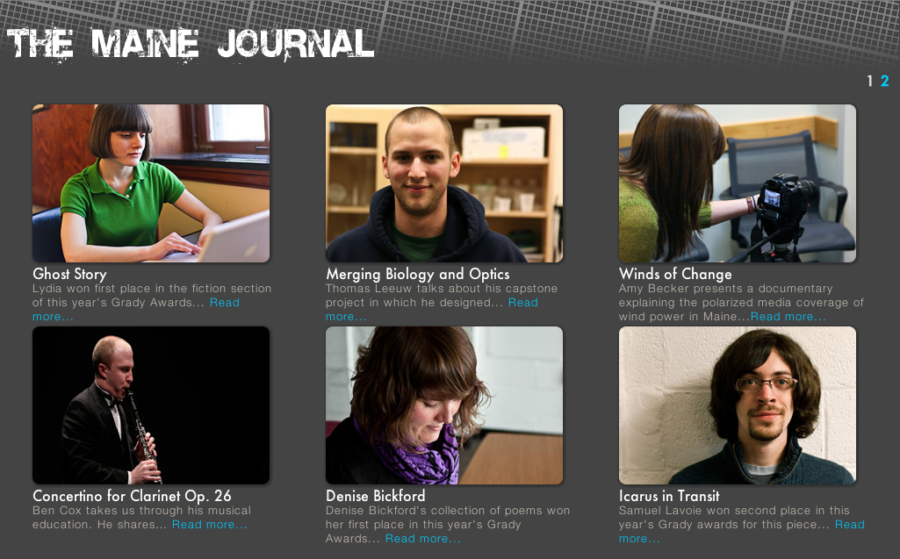

**Maine Journal Publication (Undergraduate Profile Page)**



**Maine Journal Publication CUGR Flyer**

